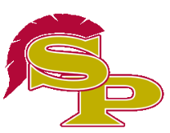
Spartan Spirit Wear Order Form

The font used will be a replica of the font used on the player’s hoodies. Orders will be collected through Saturday, February 17th. All money is due at that time. Chasity Thorpe will be at the field beginning at 1:00 p.m. for collection. She will be there through the end of the last Varsity game. Please make all checks payable to South Paulding Diamond Club. We are expecting delivery in approximately 2 weeks. Please add $3.00 for sizes 2X and up. Hoodies are available in cardinal only. All other items are available in cardinal, black and white.

Player Name:________________________________________
Item Size Quantity Color
Hoodie: (only available in cardinal) $30.00 C

Dry fit short sleeve t-shirt: $15.00

Dry fit long sleeve t-shirt: $18.00

Cotton short sleeve t-shirt: $10.00

Cotton long sleeve t-shirt: $12.00
Total Due:

